REPORT ON

DBMS MINI PROJECT

**BLOOD BANK MANAGEMENT SYSTEM**

*Submitted to*

**NMAM INSTITUTE OF TECHNOLOGY, NITTE**

(An Autonomous Institution under VTU, Belagavi)

*In partial fulfillment of the requirements for the award of the*

Degree of Bachelor of Engineering in

Computer Science & Engineering

*by*

**BHAVYA NAYAK(NNM22CS040)**

**CHAITHRA J SUVARNA(NNM22CS044)**

Under the guidance of

**Ms. Ankitha A Nayak**

Assistant Professor Grade II

Department of Computer Science and Engineering



# ABSTRACT

The Blood Bank Management System (BBMS) is a comprehensive software solution designed to streamline and optimize the processes involved in managing blood donation, storage, inventory, and distribution. This abstract outlines the key functionalities and features of the BBMS. The BBMS provides a user-friendly interface for blood bank staff to efficiently record and manage donor information, including personal details, and blood type. Furthermore, the BBMS facilitates seamless communication and coordination between blood banks and hospitals or healthcare facilities and the donors or recipients. It allows healthcare providers or recipients to place requests for specific blood products, which are then fulfilled based on availability and compatibility criteria.

Security and confidentiality are paramount in blood banking, and the BBMS incorporates robust security measures to safeguard sensitive donor and patient information. Access controls, encryption, and audit trails are implemented to prevent unauthorized access or data breaches. In summary, the Blood Bank Management System offers a comprehensive solution to enhance the efficiency, transparency, and safety of blood banking operations. By automating processes, and improving communication channels, the BBMS contributes to the overarching goal of ensuring a reliable and sustainable blood supply for patient care.

# TABLE OF CONTENTS

Title Page ...............................................................................................................1

Abstract ..................................................................................................................2

Table of Contents ...................................................................................................3

Problem Statement .................................................................................................4

Introduction .............................................................................................................4

Technology Stack ................................................................................................5-6

Database Schema…………………………………………………………………….….6

Implementation.....................................................................................................6-7

Snapshots .........................................................................................................8-11

Conclusion and Future Enhancements ……………………………………………...12

# PROBLEM STATEMENT

The current manual methods of managing blood donation, storage, inventory, and distribution in blood banks are inefficient, error-prone, and lack real-time tracking capabilities. These shortcomings often result in suboptimal utilization of blood resources, increased risk of inventory wastage, and challenges in maintaining adequate blood supply levels to meet patient needs. Additionally, the lack of standardized procedures and communication channels between blood banks and healthcare facilities can lead to delays in fulfilling blood requests and compromise patient care. Therefore, there is a critical need for a comprehensive Blood Bank Management System (BBMS) to automate processes, optimize inventory management, enhance communication, and ensure the security.

# INTRODUCTION

The Blood Bank Management System (BBMS) plays a pivotal role in ensuring the efficient and effective operation of blood banks, which are critical components of healthcare systems worldwide. Blood banks serve as vital hubs for collecting, processing, storing, and distributing blood and blood products to meet the transfusion needs of patients undergoing medical treatments, surgeries, or emergencies. However, traditional manual methods of managing blood bank operations are often marred by inefficiencies, inaccuracies, and logistical challenges.

The introduction of a comprehensive Blood Bank Management System addresses these shortcomings by leveraging technology to streamline processes, enhance transparency, and improve the overall management of blood resources. This system encompasses a range of features and functionalities designed to automate key tasks, such as donor management, inventory tracking, and blood product distribution, and user queries and feedback while ensuring compliance with regulatory standards and safeguarding patient safety.

In this context, this paper presents an overview of the Blood Bank Management System, highlighting its significance in modern healthcare delivery, the challenges it aims to address, and the benefits it offers to blood banks, healthcare providers, and ultimately, patients. By providing a reliable and efficient platform for managing blood bank operations, the BBMS contributes to the overarching goal of ensuring a sustainable and accessible blood supply for lifesaving transfusions.

# TECHNOLOGY STACK

**Frontend:**

React.js:

* A popular JavaScript library for building user interfaces. React.js offers a component-based architecture and efficient rendering, making it well-suited for developing dynamic and interactive frontend applications.

**Backend:**

Node.js:

* A runtime environment that allows developers to run JavaScript code on the server-side. Node.js provides a non-blocking, event-driven architecture, making it suitable for building scalable and high-performance backend applications.

Express.js:

* A minimalist web application framework for Node.js. Express.js simplifies the process of building APIs and handling HTTP requests, enabling rapid development of backend services.

**RDBMS:**

MySQL:

* An open-source relational database management system (RDBMS) that is widely used for storing and managing structured data. MySQL offers robust features for data integrity, scalability, and performance, making it a popular choice for backend data storage in web applications.

**Integration:**

Node.js with Express.js:

* Node.js, in conjunction with Express.js, serves as the integration layer between the frontend and the backend components of the application. It handles communication between the client-side (React.js) and the server-side (MySQL), processing requests, executing business logic, and serving data to the frontend interface.

# DATABASE SCHEMA

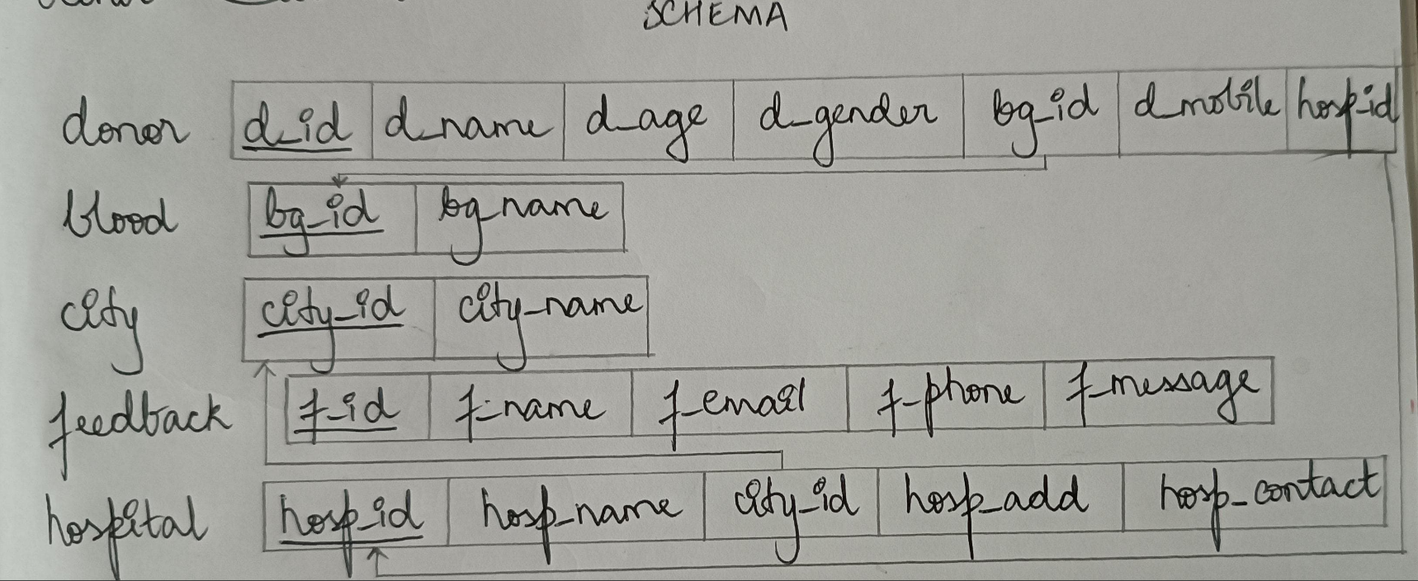

Figure 1: Database schematic diagram for blood bank management system

# IMPLEMENTATION

The following comes under implementation:

1. Initial System Setup and Configuration:

* Establishes a secure, scalable server infrastructure to host the website, ensuring it can handle varying loads with high availability.
* Configures the website to have a clear and intuitive user interface, with initial menus like "Home" and "Sign In" prominently displayed for easy navigation.

1. Donor data collection:

* Implements a user-friendly form for blood donation using React.js for frontend development.
* Collects donor information such as personal details, blood type, city and hospital.
* Validates input fields to ensure data accuracy and completeness.
* Integrates form submission with backend API endpoints built using Node.js and Express.js.
* Stores donor information securely in the MySQL database, maintaining data integrity and confidentiality.

1. Blood search functionality:

* Develops a search feature to enable users to find available blood based on blood type and city.
* Designs a search interface with React.js components for a seamless user experience.
* Implements backend APIs to handle search queries and retrieve relevant blood inventory data from the MySQL database.
* Ensures real-time updates of blood availability to provide accurate and up-to-date information to users.

1. Feedback form:

* Creates a feedback form using React.js components to gather user feedback and suggestions.
* Includes fields for users to provide comments, queries and suggestions for improvement.
* Implements backend endpoints to receive and process feedback submissions.
* Stores feedback data in the database for analysis and future enhancements.
* Integrates feedback submission with user credentials to ensure accountability and prevent misuse.

1. Admin authentication:

* Implements robust authentication mechanisms to secure admin logins, using password.
* Implements a secure authentication system for administrators using hardcoded credentails.
* Login form for administrators to authenticate and create accounts securely.

1. Admin dashboard functionality:

* An intuitive dashboard interface for administrators to manage blood bank operations and monitor system activities was designed.
* Includes features such as donor management, recipient management, blood inventory management, donation analytics, and feedback analysis.
* Implements CRUD (Create, Read, Update, Delete) operations for managing donor accounts, blood inventory records, city and hospital records and feedback data.
* Role-based access control was implemented to restrict access to sensitive functionalities based on administrative privileges.

## SNAPSHOTS

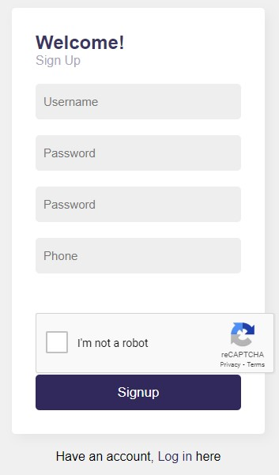

Figure 2: Sign up page for live tracker.

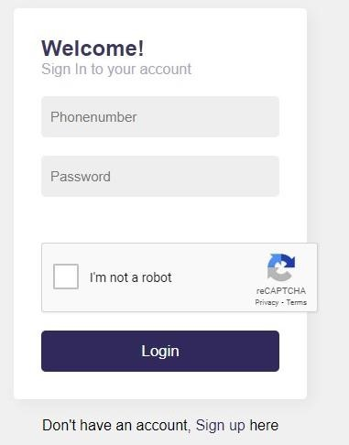

Figure 3: Sign in page for live tracker.

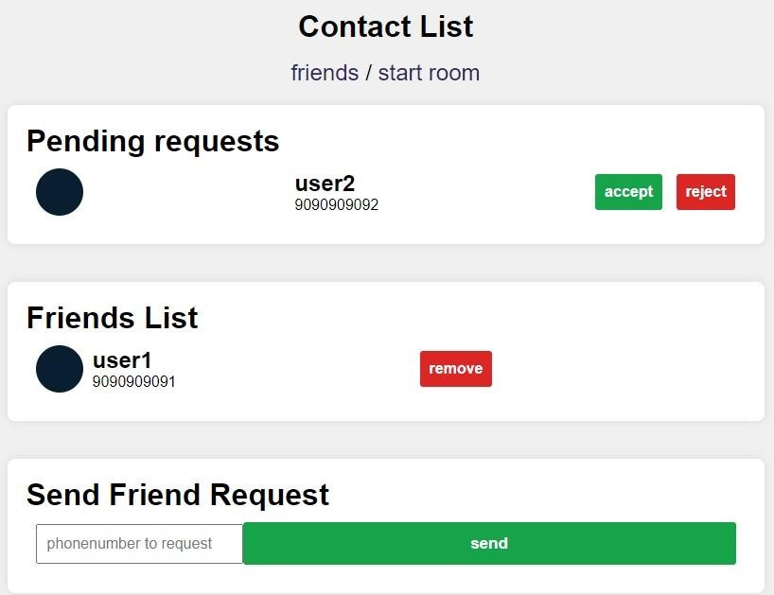

Figure 4: Contact list page for live tracker showing the friends list, has option for accepting request and to send request.

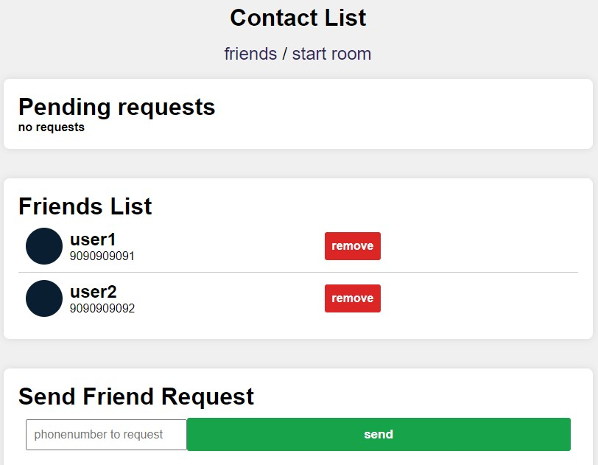

Figure 5: Contact list page after accepting the request and it also has option to remove the friends.

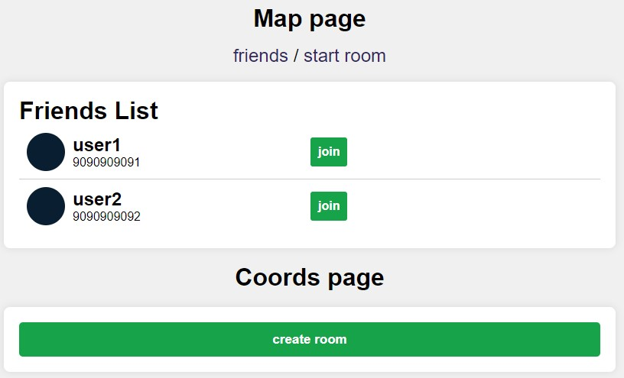

Figure 6: Map page showing the friends list and coordinates page for creating a room.

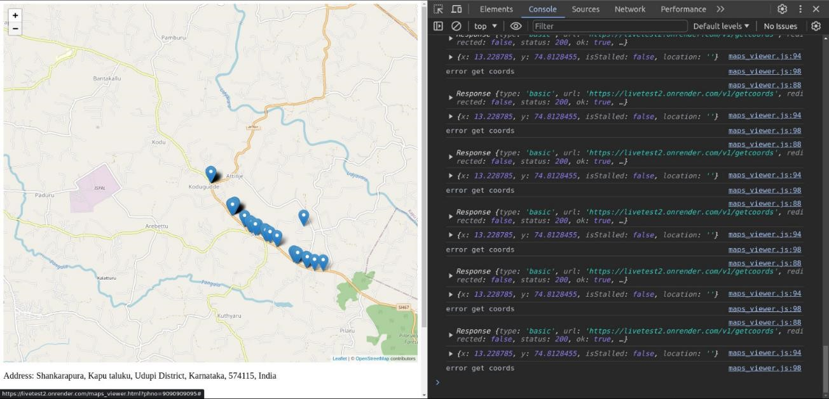

Figure 7: Above map showing the live location tracker after creating a room.

# CONCLUSION AND FUTURE ENHANCEMENTS

The implementation of the Blood Bank Management System (BBMS) has successfully addressed key requirements, including streamlining blood donation processes, facilitating blood search functionalities, collecting user feedback, and providing secure authentication and dashboard features for administrators. By leveraging technologies such as React.js for frontend development, Node.js with Express.js for backend services, and MySQL for data storage, the system offers a robust and efficient platform for managing blood bank operations.

**Future Enhancements:**

While the current implementation meets the immediate needs of the Blood Bank Management System, several enhancements could further improve functionality, user experience, and security:

1. **Enhanced Authentication**: Implement more secure authentication mechanisms such as token-based authentication using JSON Web Tokens (JWT) to enhance security and scalability.
2. **Role-Based Access Control (RBAC)**: Introduce RBAC to differentiate between different user roles and permissions, allowing for more granular access control within the system.
3. **Data Validation and Sanitization**: Implement thorough input validation and data sanitization techniques to prevent security vulnerabilities such as SQL injection and cross-site scripting (XSS) attacks.
4. **Real-Time Notifications**: Introduce real-time notifications for blood donation events, blood inventory updates, and feedback submissions to keep users and administrators informed of important system activities.
5. **Analytics and Reporting**: Develop analytics and reporting features to analyze blood donation trends, inventory utilization, and user feedback, providing valuable insights for decision-making and optimization.
6. **Mobile Responsiveness**: Enhance the system's responsiveness and compatibility across various devices and screen sizes, including mobile devices, to improve accessibility for users.
7. **Integration with External Systems**: Explore integration with external systems such as electronic health record (EHR) systems, hospital management systems, and government blood donation registries to facilitate seamless data exchange and interoperability.
8. **Continuous Testing and Security Audits**: Conduct regular security audits and penetration testing to identify and address vulnerabilities, ensuring the system's resilience against potential threats and attacks.

Incorporating these enhancements will further strengthen the Blood Bank Management System, making it more secure, user-friendly, and feature-rich, thereby improving its effectiveness in managing blood bank operations and serving the needs of healthcare providers and patients.